Pardner Hand: A Caribbean answer to British banking exclusion
An exhibition from Museumand, The National Caribbean Heritage Museum

Museum activity sheet for key stage 3

As you explore the exhibition, answer the questions below.

- When did the HMT Empire Windrush arrive in the UK?

- Identify two reasons Windrush migrants found it difficult to open a bank account in the UK.

- List three things Windrush migrants would have used the Pardner Hand scheme for following their arrival in the UK.

- What might be the risks associated with entering a Pardner scheme?

- Why can Pardner be seen as both a saving and a borrowing scheme?

- What reasons are given to help explain why Pardner Hand is still used in the UK today?

- Why did people turn to Pardner following the Windrush scandal in 2018?

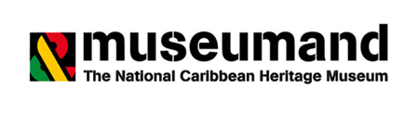

- How is Pardner Hand being future-proofed?

- What does this statue in Waterloo Station, London suggest about how the Windrush Generation felt about their move to the UK?
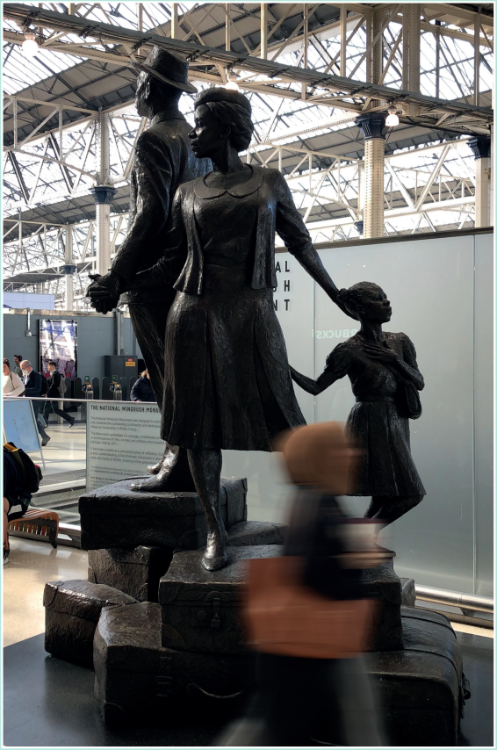
________________________________________________________________________________________________________________________________________________________________________________________________________________________________________________________________________________________________
The National Windrush Monument by Basil Watson (2022), in Waterloo Station, London
You can find out more about our exhibition by visiting our website.
