Pardner Hand: A Caribbean answer to British banking exclusion
An exhibition from Museumand, The National Caribbean Heritage Museum

Key stage 4 History: the experience of Caribbean migrants

GCSE-style questions to support the Edexcel and OCR GCSE History specification.
Please answer the following questions:
1 Describe two features of Pardner Hand.
2 How useful are Sources A and B for an enquiry into the experience of Caribbean migrants (1959)? Explain your answer, using Sources A and B and your knowledge of the historical context.
3 Explain one way in which opportunities for Huguenot migrants in the seventeenth century were different from opportunities for Caribbean migrants in the twentieth century.
----------
Source A – Spoken testimony from Lenny, recorded during the opening of the Pardner Hand Exhibition at the Bank of England in 2023, speaking about his experience of Pardner Hand.
Yeah, I've been in the Pardners. My father introduced me to it because they didn't, couldn't rather, get no money from the banks. So, they went into this Pardner, and that's how he got his money to buy his first house over here from the Pardner. Although he came with a lot of money also and that helped to send us to school, buy furniture and all sorts. My dad came in the fifties from Jamaica. From Jamaica he came. When he came, he said that the, you know, the big properties were about £1,000. And he came with more than that.
----------
Source B – A photograph and text from the Pardner Hand Exhibition by The Bank of England and Museumand in 2023
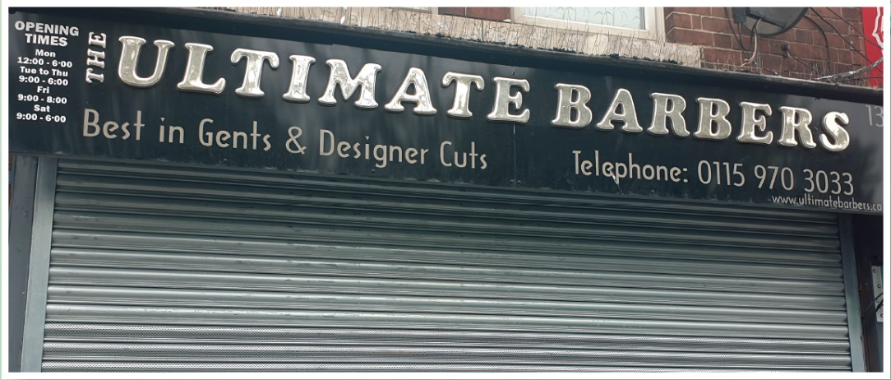

In the early days of the Windrush era, UK hair salons didn’t know how to care for Black hair. Caribbean hairdressers and barbers opened their own home salons using Pardner money, while others produced Black haircare products and styling accessories.

Teacher notes
Please use the following suggestions to help check student understanding.
- Describe two features of Pardner Hand.
- Use of a banker, a trusted member of the hand.
- Regular saving, usually weekly or monthly.
- No interest paid on savings or loans.
- Acts as an interest-free loan
- Used by members of the Windrush generation to help establish themselves in the Britain, buying property and business.

- How useful are Sources A and B for an enquiry into the experience of Caribbean migrants?
Source A
- This source is useful as it details the different purchases enabled through Pardner Hand such as furniture and housing, helping Caribbean migrants settle in the Britain.
- Useful as discusses personal experience as well as secondary experience of Pardner Hand, illustrating how the Pardner Hand became a generational practice.
- Useful as details how Caribbean migrants needed to enter a Pardner Hand for larger purchases such as houses, despite arriving with large amounts of savings, illustrating the exclusion from established banking in Britain.
Source B
- Useful as illustrates how Caribbean migrants’ personal needs were not catered for when they arrived in Britain.
- Useful as shows that there were opportunities to open business to cater for the Caribbean community.
- As a modern photograph, suggests the businesses opened by the Windrush generation were successful over a prolonged period.

- Explain one way in which opportunities for Huguenot migrants in the seventeenth century were different from opportunities for Caribbean migrants in the twentieth century.
Huguenot migrants
- They had the freedom to practice their religion without persecution.
- Moved to areas where there was already a Huguenot population so were given opportunities by their community.
- Were able to use their skills in trades such as textiles to earn money and became wealthy.
Caribbean migrants
- Their skills and qualifications were not always recognised, therefore they often went into low-paid employment.
- Experienced racism and often treated with suspicion from the White British population and had less housing opportunities available.

You can find out more about the exhibition by visiting our website.

