Indexation
- The following formula will be used to determine the Cash Ratio Deposit (CRD) ratio and is calculated every six months.
$$CRD ratio=\frac{Target income}{Aggregate eligibile liabilities*Portfolio yield}$$
- Where target income will be fixed at £169 million and aggregate eligible liabilities will be fixed at £2,837,817.5 million as specified in the statutory instrument.
The portfolio yield
- The portfolio yield will be recalculated every six months, and consists of three components weighted as per below:

$$Portfolio yield=0.55 \left(average of 8yr gilt yields over prior 13 years\right)+0.42 \left(average of 8yr gilt yields over May 2018 to Nov 2018\right)+0.03 (average of 8yr gilt yields over prior six months)$$

- It is based on an eight-year gilt yield, chosen to reflect the average duration of the Bank’s portfolio. The portfolio generally holds purchases to maturity.

- The first term represents long-term holdings, and is proxied by a historical average of yields over a lookback period of 13 years, chosen to most accurately represent the Bank’s current gilt portfolio. The weight, on this part of the portfolio is 55% of the overall portfolio yield.

- The second term is required due to the initial increase in the size of the deposit during the transition to the new mechanism. This means a significant part of the portfolio will be invested in mid-2018, and exposed to prevailing market yields in this period. The weighting on this portfolio increase is 42% of the portfolio yield. For the first six-month period starting in June 2018, this will use the average of eight-year gilt yields in the prior six months (i.e. to May 2018), as a proxy for the likely level of yields over the subsequent six months. From the second six-month period onward (starting December 2018), the average of eight-year gilt yields over the first period will be known with certainty, and so this term will become a constant.

- The third term reflects the expected re-investments from maturing holdings over the following six months. The yield on the forthcoming investments will not be known with certainty, and so will be estimated using the most recent six-month average of eight-year gilt yields. The weighting on reinvestments is 3% of the portfolio yield.

Worked example
- The target income is fixed at £169 million per year. The aggregate eligible liabilities term is also fixed at the average for the five-year period, at £2,837,817.5 million.

- For illustration purposes, the below sets out the calculations for the first two periods.

- In the first period, from June 2018, the ratio is calculated based on the following assumptions:

- the average of eight-year gilt yields over the prior 13 years to May 2018 = 2.5%
- the average of eight-year gilt yields over the prior six months (November 2017 to May 2018) = 1.2%
- at this point, yields over May 2018 to November 2018 in the second term of the formula are not yet known, so the average of eight-year gilt yields over the prior six months (November 2017 to May 2018) was also used as a proxy = 1.2%
- In this case, the portfolio yield would be:

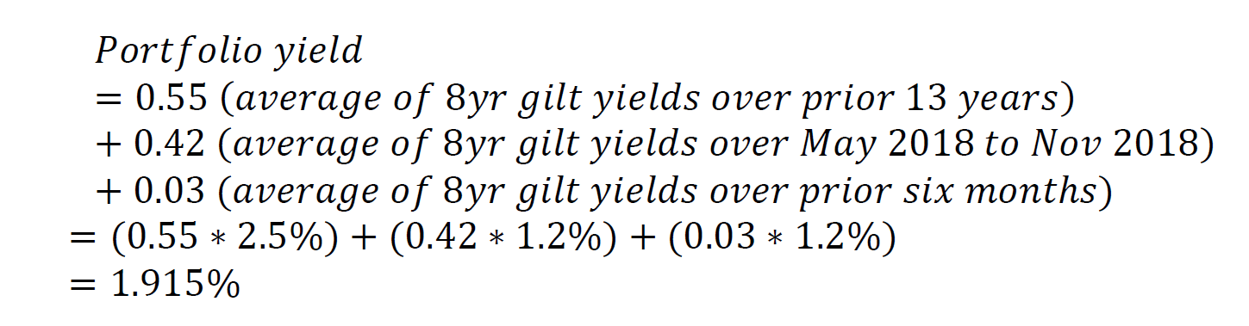

- The resulting CRD ratio would be:
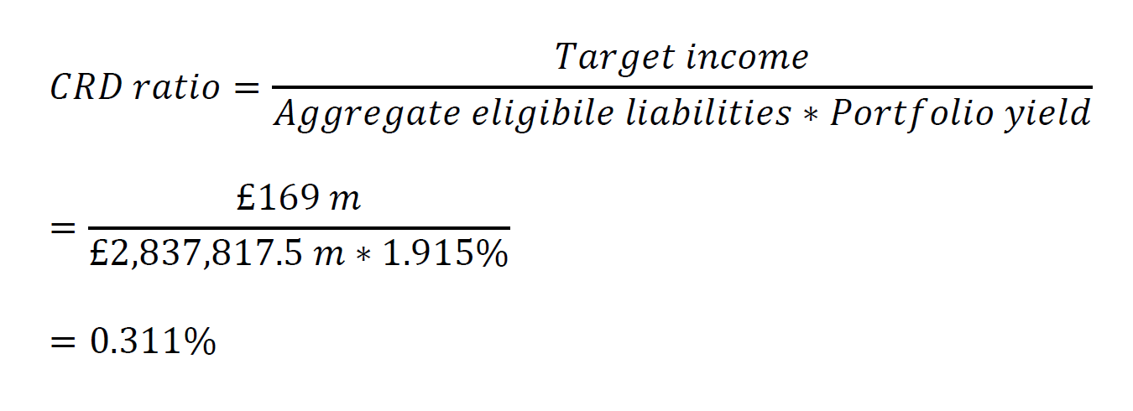

- In the following period beginning in December 2018, this example assumes the actual average of eight-year gilt yields over May 2018 to November 2018 was 1.0%, and the average over the prior 13 years had fallen to 2.4%. The second term of the portfolio yield calculation will now be fixed at (0.42 * 1.0%), and become a constant in future calculations. The third term, which uses eight-year gilt yields over the prior six months, will now also refer to May 2018 to November 2018, and 1.0%. The new portfolio yield would be:

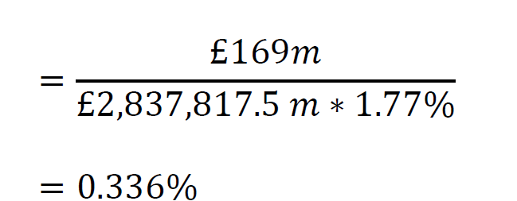

Operational considerations
- The operation of an indexation-based approach would fit within the existing timetable for call notices. The ratio would be calculated on the fourteenth working day of May and November. The gilt yield data averaged in the calculation would be of weekly frequency, using yields from the last working day of each week, up to and including the thirteenth working day of May or November. The Bank would then issue call notices to eligible institutions.

- For the purpose of calculating the ratio the Bank would publish the necessary series of eight-year gilt yield data on its website. This data would be sourced from a third-party vendor. The Bank would also publish the portfolio yield, including the results of the three terms in the portfolio yield calculation, and the final CRD ratio, on its website shortly after calculation.

Equivalent to the total budget divided evenly into five years.

